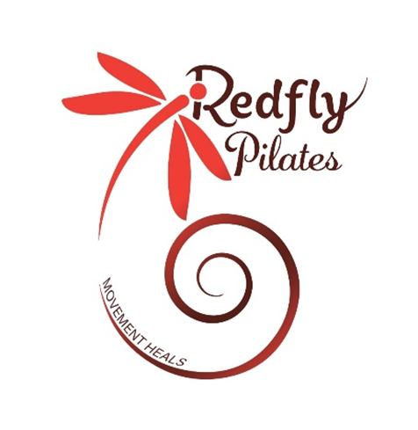

Health and safety questionnaire - PAR-Q

Name:____________________________ Telephone:________________________
Address: ____________________________________________________________
______________________________________Post code_____________________
Occupation: ____________________________ DOB: _____________ Male/Female
Emergency contact name:______________________ Telephone number:___________________

Medical history
- Have you ever suffered from heart trouble? YES / NO
- Are you presently taking any form of medication? YES / NO
- Do you suffer from chest pains? YES / NO
- Do you ever have spells of dizziness or feel faint? YES / NO
- Have you ever had either high or low blood pressure, and/or high cholesterol level?
If YES please indicate which: YES / NO
- Have you ever had asthma, chronic bronchitis or any other
chest ailments? If YES Please indicate which: YES / NO
- Do you suffer from back pain or any orthopaedic problem? YES / NO
If YES please indicate which:
- Do you suffer from severe headaches or migraines? YES / NO
- Are you recuperating from a recent illness/operation or injury? YES / NO
If YES please expand:
- Have you any medical condition that we should be aware of? YES / NO
- Are you pregnant? If yes, how many months? YES / NO
- Is there any history of heart disease in your immediate family (under the age of 55)? YES / NO
- Are you allergic to latex? YES / NO
- I hereby authorise Redfly Pilates permission to use my image in any promotional materials or content such as Facebook or Instagram. Photographs, film/video or audio recordings. YES / NO

PLEASE NOTE: If you answered YES to any of questions 1-13, you are advised to seek medical advice/approval before commencing an exercise induction or exercise programme or consult further with your instructor.
I have been informed both verbally and in writing that if I answer YES to any of questions 1-13 of this questionnaire, I should seek medical advice/approval before commencing an exercise programme and/or induction. If I wish to continue without such advice I do so entirely at my own risk. I confirm that I have read, fully understood and answered the above questions honestly. I understand that Redfly Pilates instructor, the centre and any of its employees cannot be held responsible for any injuries or ill health arising from my participation in the exercise programme.

Signed:____________________ Print name:_________________ Date: ____________________
Instructors signature: ___________________________

